**2018-2019 Measles Outbreak Analysis**

**IBM Data Science Capstone Project**

**Devin Zimmerman**

**Introduction**

* 1. **Background**

Measles is a highly contagious viral disease and remains an important cause of death among young children globally, despite the availability of a safe and effective vaccine. Measles is transmitted via droplets from the nose, mouth or throat of infected persons. Symptoms include high fever, a runny nose, bloodshot eyes, and tiny white spots on the inside of the mouth. While global measles deaths have decreased by 84 percent worldwide in recent years — measles is still common in many developing countries, particularly in parts of Africa and Asia. An estimated 7 million people were affected by measles in 2016. Routine measles vaccination for children, combined with mass immunization campaigns in countries with low routine coverage, are key public health strategies to reduce global measles deaths. The measles vaccine has been in use since the 1960s. It is safe, effective and inexpensive for obtaining the two required doses. WHO recommends immunization for all susceptible children and adults for whom measles vaccination is not contraindicated i.e. immunity is low due to illness or age under the recommended dosing schedule.

* 1. **Problem**

Even though the measles vaccine is a tested and approved way to combat this disease, with the raise of Anti-Vaccination movements, measles cases have increased across the United States and other developed nations such as France and other parts of the EU. From January 1 to August 15, 2019, 1,203 individual cases of measles have been confirmed in 30 states. This is an increase of 21 cases from the previous week. This is the greatest number of cases reported in the U.S. since 1992 and since measles was declared eliminated in 2000. Most cases are among people who were not vaccinated. This new wave of measles outbreaks poses a great public health risk to communities like infants and people have can’t obtain vaccinations due to low immunity.

* 1. **Interest**

This analysis will present the impact of the measles outbreak on a state level, national level and global level. With these breakdowns, we can determine ways to combat transmission by enhancing community health initiatives and public education regions/areas and understand the cause of the outbreaks.

**Data Acquisition**

**2.1 Data Sources**

Most of the data sources were obtained through the Center for Disease Control (CDC) and World Health Organization (WHO) websites. The had multiple sources that tracked the amount of unvaccinated people that were affected by the outbreak, what ages they were, and what communities were affected. I also used the state public health department websites to track down specific zip codes of the communities affected as well as reasoning behind the outbreak i.e. Atlanta area was affected because of the high international travel.

* 1. **Data Cleaning**

To prepare the data for analysis, I tried tofind connections among data sheets by examining the individual excel sheets and changed variables to have cohesion among the sheets i.e. WHO defined regions with the series of vaccination given (MM1 and MM2). I removed different columns that don't pertain to data for my analysis. It also required a comprehensive review of outliers and null values to normalize the data as well as correct formatting issues within excels. Overall, the data cleaning process took the longest part of the analysis to ensure that the data would populate as accurately as possible.

* 1. **Features**

Once the examined the data, I was able to determine the features that I wanted to highlight in this analysis. I chose to focus on the county data, state level data and national data of the measles outbreak while also reviewing the months of the outbreaks to determine if transmission was higher during months of the year. I felt it was also important to review the data of how many people were receiving the full dose, obtaining the two separate doses, since that is the most effective way for the vaccine to combat measles. Examining these features and drilling down would be effective in helping determine how and when to begin educational outreach to specific communities most vulnerable to transmission of measles.

*Table 1. Feature Selection for Measle Outbreak Analysis*

|  |  |
| --- | --- |
| **Features Selected** | **Reasoning for Review** |
| State Level Confirmed Measle Cases | Understand the amount of state confirmed cases to interpret reasons for transmission, environmental factors, etc. |
| National Level Confirmed Measles Cases | Tracks amount of cases from 2018 to 2019 per month, helping interpret the level of transmission |
| NY County Confirmed Measles Cases | County level breakdown highlights the spread of transmission in the state most affected by the outbreak |
| MMR Vaccination Dose Information | Learn if population is obtaining the required two doses for Measles and interpret ways to target communities not receiving full dose |
| Globally Confirmed Measles Cases | Compare measles cases globally and the impact of the outbreaks |
| WHO Defined Region of Measles Cases for 2018 and 2019 | This information breaks down measles cases by region and continues to give insight and tracking of measle cases globally |
| NY Breakdown of Dose/Unvaccinated Confirmed Cases | This information breaks down the amount of cases based on age groups and if they received one or two doses of the vaccine. Having this information can help us understand which communities are at risk and how to communicate more effectively |

**Methods**

3.1 Exploratory Analysis

**2019 NY State Breakdown:** show in both the chart and map above, the measles outbreak affected New York state the most, with the highest amount of confirmed cases in the 2018-2019 period. I decided to breakdown the neighborhoods of New York City and analyze which neighborhood had the highest amount of cases and potentially investigate the community factors that could have contributed to this measles outbreak. 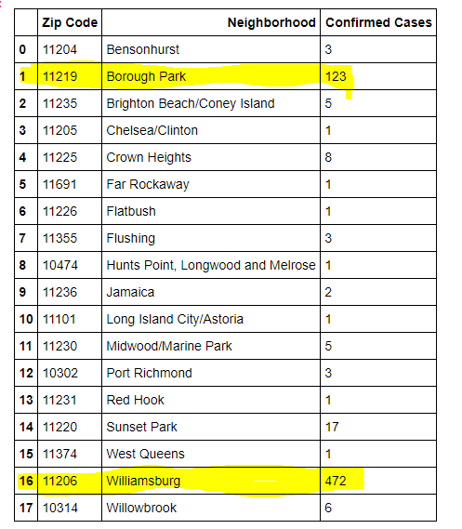

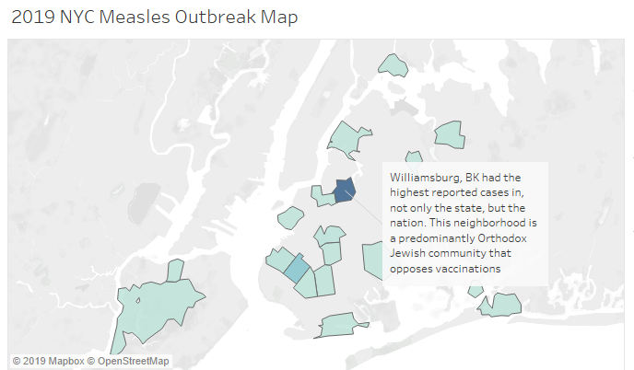

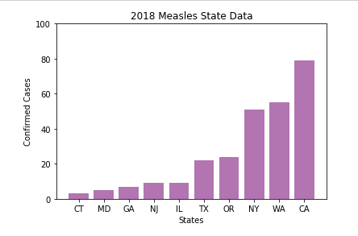

**2018 Measles State Data:** Reviewing the state data from each state’s Department of Health showed that the highest confirmed cases were in high transient and international traffic

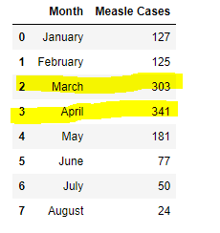

**2019 Month Breakdown:** Analyzing the month breakdown of 2019 allowed an understanding of the highest transmission periods and when to potentially target campaigns for vaccinations.

**10 Year Breakdown of MMR Dosing:** In 2018, we see the highest measles coverage for both required doses of the MMR vaccines at 92% and 94% of the US population. With this gap closing, we still saw increased number of reported cases in the US. In 2018 and 2019, measles cases surged with a 300 percent increase globally, according to the World Health Organization (WHO)

**10 Year Breakdown of MMR Dosing:** In 2018, we see the highest measles coverage for both required doses of the MMR vaccines at 92% and 94% of the US population. With this gap closing, we still saw increased number of reported cases in the US. In 2018 and 2019, measles cases surged with a 300 percent increase globally, according to the World Health Organization (WHO)

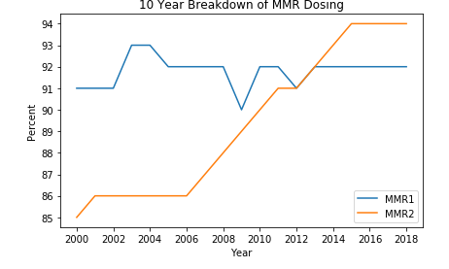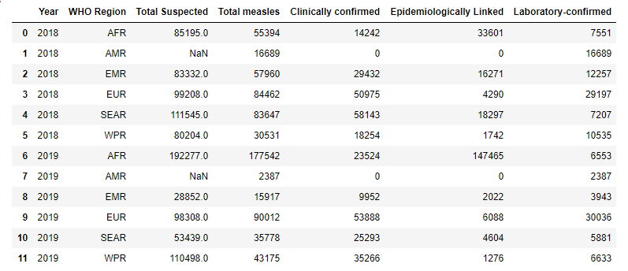

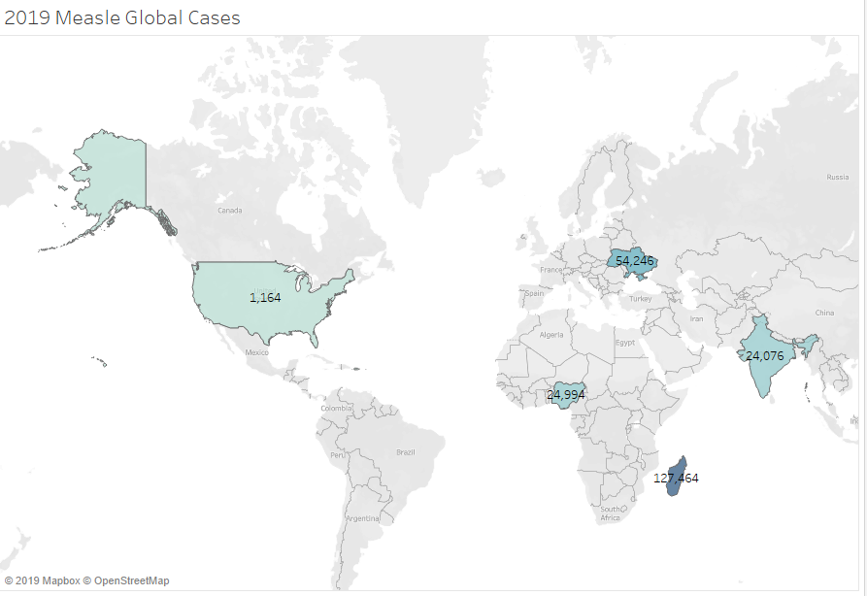

The 2019 Measles Global Cases Map shows the U.S. compared to countries with some of the highest confirmed cases. As seen in the Global Measles Case Breakdown, all the confirmed cases were Laboratory Linked, meaning that the patient may or may not have known they had measles prior to seeking treatment.

**Results**

While reviewing the individual data sets and visualizations completed, several insights regarding transmission, vaccination coverage and global reach of the 2018/2019 measles outbreak. Among the national measles outbreak, New York had the highest reported cases, most residing in the New York City area. The Williamsburg neighborhood in Brooklyn had the highest confirmed cases at 472 cases. In the table above, many cases in New York state were unvaccinated children under the age of 17. This area is known for high skepticism related to vaccinations as well as religious views that prevent community members from obtaining the measles vaccine. Because of the high international traffic and proximity, transmission of measles spread rapidly among the neighborhoods into other parts of the states across the nation. The highest reported cases were in other cities such as Los Angeles, Atlanta, and Seattle with increased international foot traffic.

Transmission via airborne respiratory droplets shows higher reported cases in the winter and early spring months. Since more people are indoors and susceptible with the lower temperatures, measles can spread quicker and remain infectious in the air for up to two hours after an infected person leaves an area. Because of this, communications to communities to vaccinate and prepare accordingly should begin in the summer and early fall to decrease the rate of transmission. Even with the high rate of Vaccine Administration in 2018 for both two required doses, the US still had the highest amount of confirmed cases seen since 1992. Most of the US cases seen were during high transmission months (winter) and among unvaccinated populations, the 6-8% of the population NOT covered by the vaccine.

In 2018, we see the highest measles coverage for both required doses of the MMR vaccines at 92% and 94% of the US population. With this gap closing, we still saw increased number of reported cases in the US. In 2018 and 2019, measles cases surged with a 300 percent increase globally, according to the World Health Organization (WHO). The 2019 Measles Global Cases Map shows the U.S. compared to countries with some of the highest confirmed cases. Each country has different reasons that have contributed to the spread of measles such as vaccine refusal, access issues to healthcare and vaccines, civil unrest and low awareness about the vaccination benefits. All these factors lead to low vaccination coverage for susceptible populations. The US has the highest amount of skepticism with vaccinations. As seen in the Global Measles Case Breakdown, all the confirmed cases were Laboratory Linked, meaning that the patient may or may not have known they had measles prior to seeking treatment.

**Discussion**

The results were insightful to several contributing factors that the communities were affected most by the measles outbreak, the high transmission periods and national impact. Neighborhoods like Williamsburg in New York with higher rates of confirmed cases had the highest rates of confirmed cases in the nation with higher rates of unvaccinated children and skepticism related to vaccination. Because of this, public health initiatives in this area should focus on the population and conduct further analysis as to the barriers of getting their children vaccinated while educating on the signs and symptoms of measles. Transmissions rates were higher in winter months since immunity is lower during colder months. Public health initiatives and efforts could begin in the summer/early fall so that the community can access the vaccine before the higher transmission rates. It’s also important to include education about the signs and symptoms if patients decide to forgo the vaccine; having patients know the symptoms and seek treatment earlier can lead to less transmission of measles. Health organizations should continue to provide education to health care providers so they can disseminate the information about dosing and the effects of not vaccination and suffering from measles. Even with the increase in people obtaining the required two doses of the vaccine, education should include that the effectiveness with the two doses decreases the chances of getting measles.

**Conclusion**

The analysis was insightful to issues and contributing factors related to the rise of measles outbreaks in the US and globally. With these insights, public and global health departments can target and address communications issues to educate communities on the risk of measles. Because of the limited data on how impactful education tools are on communities related to vaccinations, I would recommend a longitudinal study to monitor the implementation of new educational initiatives in high outbreak areas. It would also be beneficial to perform a deeper analysis of other developed nations affected by these outbreaks and find a common denominator to what is contributing to these outbreaks. With this analysis and insights provided, we can hopefully combat issues related to vaccination and measles and once again, eliminate this disease.

**References**

https://www.cdc.gov/measles/transmission.html?CDC_AA_refVal=https%3A%2F%2Fwww.cdc.gov%2Fmeasles%2Fabout%2Ftransmission.html

https://www.cnn.com/2019/04/19/health/new-york-measles-outbreak-passover-williamsburg/index.html

https://www.sciencemag.org/news/2019/02/measles-cases-have-tripled-europe-fueled-ukrainian-outbreak

https://www.vox.com/2019/4/15/18311377/measles-outbreak-2019

https://www.cdc.gov/measles/cases-outbreaks.html